Introduction to Spring Boot

Table of Contents

What is Spring Boot? 2

Advantages of Spring Boot 2

Configure a Spring Boot Project 3

Eclipse 3

Spring Tool Suite 3

Project Structure 4

JSP View in Spring Boot 6

JPA (Java Persistent API) 6

What is JPA? 6

Why ORM? 6

JPA API 6

CRUD Operations 6

# What is Spring Boot?

Spring Boot is a project that is built on top of the Spring Framework.

Funnily said - **Spring Boot is Spring on steroids**. It's a great way to get started very quickly with almost the entire Spring stack.

1. Spring Boot is a module of Spring from which we can speed up development
2. Spring Boot makes it easy to create stand-alone, **production grade** Spring based Applications that we can just run
3. It provides an easier and faster way to set up, configure and run both - simple and web based applications
4. **Spring Boot** = **Spring Framework + Embedded Servers – Configuration**

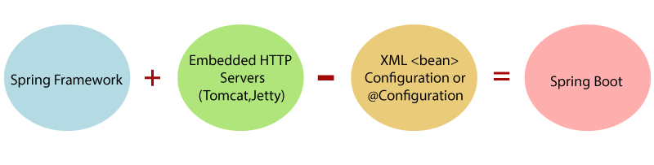

1. Spring boot follows “**Convention over Configuration**” software design style, i.e. if we follow spring boot’s coding and project conventions, Spring boot will take care of the configurations. It decreases the effort of the developer
2. Spring Boot follows “**Opinionated Defaults Configuration**”, i.e. if we include “spring-boot-starter-data-jpa”, Spring Boot will automatically configure - in memory database, a hibernate entity manager, and a simple data-source. Spring Boot scans the class path and find the dependency and then it will automatically configure the things

## Pros of Spring Boot

1. It creates stand-alone Spring Applications that can be started using Java –jar, we don’t need war file
2. It **embeds** Tomcat, Jetty or Undertow directly (no need to deploy WAR files)
3. Provide opinionated 'starter' dependencies to simplify our build configuration
4. Automatically configure Spring and 3rd party libraries whenever possible
5. Provide production ready features such as metrics, health checks, and external configuration
6. It reduces lots of development time and increases productivity.
7. It **avoids** writing lots of **boilerplate** Code, Annotations and XML Configuration.
8. It is very **easy to integrate** Spring Boot Application with its Spring Ecosystem modules like Spring JDBC, Spring ORM, Spring Data, Spring Security etc.
9. It provides CLI (**Command Line Interface**) tool to develop and test Spring Boot (Java or Groovy) Applications from command prompt very easily and quickly
10. It **provides** lots of **plugins** to develop and test Spring Boot Applications very easily using Build Tools like Maven and Gradle

## Cons of Spring Boot

Spring Boot can use dependencies that are not going to be used in the application. These dependencies increase the size of the application.

## Version History of Spring Boot

1. Spring Boot 1.0 was released in April 2014
2. Spring Boot 2.0 was released in January 2017
3. Latest current version is **Spring Boot 2.5.3**

# Spring Boot Architecture

Spring Boot follows a layered architecture in which each layer communicates with the layer directly below or above (hierarchical structure) it.

Before understanding the **Spring Boot Architecture**, we must know the different layers and classes present in it. There are **four** layers in Spring Boot are as follows:

1. Presentation Layer
2. Business Layer
3. Persistence Layer
4. Database Layer

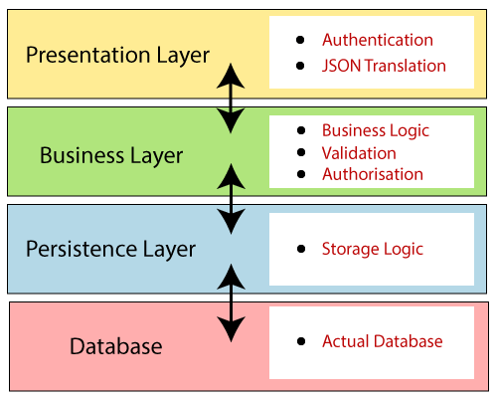

## Presentation Layer

The presentation layer handles the HTTP requests, translates the JSON parameter to object, and authenticates the request and transfer it to the business layer. In short, it consists of **views** i.e., frontend part.

## Business Layer

The business layer handles all the **business logic**. It consists of service classes and uses services provided by data access layers. It also performs **authorization** and **validation**.

### Persistence Layer

The persistence layer contains all the **storage logic** and translates business objects from and to database rows.

### Database Layer

In the database layer, CRUD (create, retrieve, update, delete) operations are performed.

## Spring Boot Flow Architecture

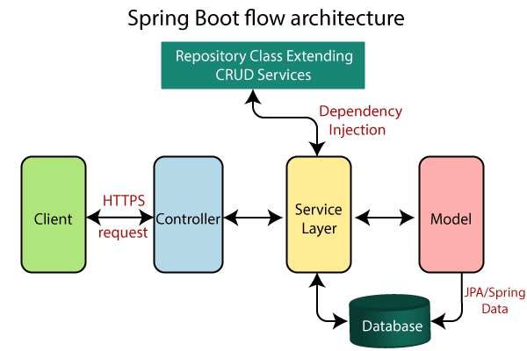

Steps:

1. The client makes the HTTP requests
2. The request goes to the controller, and the controller maps that request and handles it.
3. After that, it calls the service logic if required.
4. In the service layer, all the business logic performs.
5. Service Layer performs the logic on the data that is mapped to JPA with model classes.
6. A JSP page is returned to the user if no error occurred.

# Configure a Spring Boot Project

There are following ways to create a Spring Boot project:

1. Using Eclipse: Create a maven project in Eclipse and add starter dependencies
2. Use Spring Initializr and Eclipse/STS
3. Use Spring Tool Suite IDE
4. Spring Boot Command Line Interface

### Eclipse

Eclipse is the most used IDE by Java Developers, so Spring Boot provides an initializer to make things easy for eclipse users.

#### Steps to create Spring Boot Application in Eclipse

1. Step 1: Search for Spring Boot Initializer
2. Step 2: Go to <https://start.spring.io/>
3. Step 3: Choose the options for the project:
   1. Project – Maven Project,
   2. Language – Java,
   3. Spring Boot – 2.3.5,
   4. Project Metadata,
   5. Packaging – Jar,
   6. Java – 11
4. Step 4: Add Dependencies
   1. Web
5. Step 5: Click Generate: The project will be downloaded as a zip file. Extract it.
6. Open Eclipse and Import the extracted project as “Existing maven Project”

### Spring Tool Suite

Spring Tool Suite is an IDE to develop Spring applications. It is an Eclipse-based development environment. It provides a ready-to-use environment to implement, run, deploy, and debug the application. It validates our application and provides quick fixes for the applications.

#### Steps to create Spring Boot Application in STS

1. Step 1: Search for STS download
2. Step 2: Go to: <https://spring.io/tools>
3. Step 3: Download 64 bit STS windows version (here 4.8.1)
4. Step 4: Execute the file by double clicking it
5. Step 5: Go to File>> New >> Spring Starter Project
6. Step 6: Choose the options for the project:
   1. Type – Maven
   2. Packaging – Jar
   3. Java Version - 17
   4. Language – Java,
   5. Spring Boot – 2.3.5,
   6. Project Metadata, such as project name and package
   7. Packaging – Jar,
   8. Java - 15
7. Step 4: Add Dependencies
   1. Web

**Note: We will use STS in our course to gain familiarity with it**

### Project Structure

#### Java Source Code

1. All the java source code must reside inside **src/main/java** folder.
2. The package we mentioned while making the project (here spring.boot.demo) must be considered as a base package for all the java classes hereafter, i.e. all the Java files **must** either lie inside this package or **must be** written inside the sub package of this package for Spring Boot to scan them.
3. In this example, the class SpringDemoApplication is the java class from where the execution will begin.
4. SpringDemoApplication is annotated with **@SpringBootApplication** annotation. This annotation is the combination of following annotations:
   1. @Configuration,
   2. @EnableAutoConfiguration, and
   3. @ComponentScan
5. Just run the application as Java Application in Eclipse or Run As>>Spring Boot App in STS.

#### Resources

1. All the static resources, **configurations** and **themes** are kept in this folder
2. **Static**: All the static resources such as **HTML, CSS, JavaScript, images and other media** files are contained in static folder.
3. **Themes**: It will contain any predefined themes such as for example: Thymeleaf.
4. File **application.properties**: All the properties such database configurations, context path, file path configurations must be done in application.properties file with the help of **key=value** pairs

#### Dependencies

We add **starter template jars** to our spring boot application such as: **spring-boot-starter-web**, **spring-boot-starter-data-jpa**, etc

When we add starter jars, then Spring Boot pulls all the related jars. These Jar files contain the file spring.factories in META-INF folder, i.e. META-INF/spring.factories

If we use JPA, JPA configurations become active.

Spring boot scans the class path and if it finds JPA, all the configurations relating to JPA in spring.factories will become active, this will download spring.orm, hibernate, mysql connector etc

This is known as “Opinionated Defaults Configuration”

## JSP View in Spring Boot

In order to use JSP in a Spring Boot application, follow the below steps

1. Include **tomcat embedded jasper** maven dependency in pom.xml
2. Create some folders: a **webapp>>views** folder in **src>>main** folder
3. Place the JSPs in it
4. Set the following properties in **application.properties**
   1. spring.mvc.view.prefix=/views/
   2. spring.mvc.view.suffix=.jsp
5. Create a controller with a request handler to show JSP
6. Fire the request through the URL

# JPA (Java Persistent API)

## What is JPA?

* By name, JPA stands for Java Persistent API, i.e. it is an Application Programming Interface (a set of interfaces and classes) that is used to persist (manipulate and store) data.
* In other words JPA is a specification. It is a specification that lays down the specifications for Object Relationship Mapping (ORM). It is implemented by Hibernate, Open JPA, Eclipse link etc. Hibernate is the most used one.
* JPA specification is given by Oracle, Hibernate is written by Gavin King

## Why ORM?

* With ORM, developers can transact with database without having to write tedious SQL Queries
* Reduction of manual database handling saves time plus helps developers to write less erroneous code.
* Less errors mean less time is consumed in testing and development cycles

## JPA API

It provides following 2 interfaces:

1. EntityManagerFactory: It will provide the object of EntityManager object
2. EntityManager: It will provide methods to do CRUD

# CRUD Operations

1. Step 1: Create a new Spring Boot Starter project in STS
2. Step 2: Add the following dependencies in the Spring Boot Project:

* Spring Boot Starter Data JPA
* MySQL Connector

1. Step 3: Fill in the project details
2. Step 4: Create an entity (for ex User, **Book**, Person, Product etc.) that we need saving. Just remember to create it inside the parent package.
3. Step 5: Create an interface: BookRepository and extend it with CRUDRepository interface
   1. This BookRepository will be same as DAO in the data layer.
   2. It will extend an interface CRUDRepository
   3. CRUDRepository takes in 2 generic parameters: 1st: Entity Class and 2nd **type** of Entity Id. For Example: CRUDRepository<Book, Integer>
   4. We can also make it extend the child interface of CRUDRepository: JPARepository, it has some extra features.
4. Configure datasource in application.properties files
   1. spring.datasource.name=test
   2. spring.datasource.url=jdbc:mysql://localhost:3306/spring_boot_crud?serverTimezone=UTC
   3. spring.datasource.username=root
   4. spring.datasource.password=1234
   5. spring.datasource.driver-class-name=com.mysql.cj.jdbc.Driver
   6. spring.jpa.properties.hibernate.dialect= org.hibernate.dialect.MySQL55Dialect
   7. spring.jpa.hibernate.ddl-auto=update
5. Get the ApplicationContext from SpringApplication.run() method
6. Get an object of BookRepository from applicationContext.getBean() method
7. Use save method on BookRepository object to save data